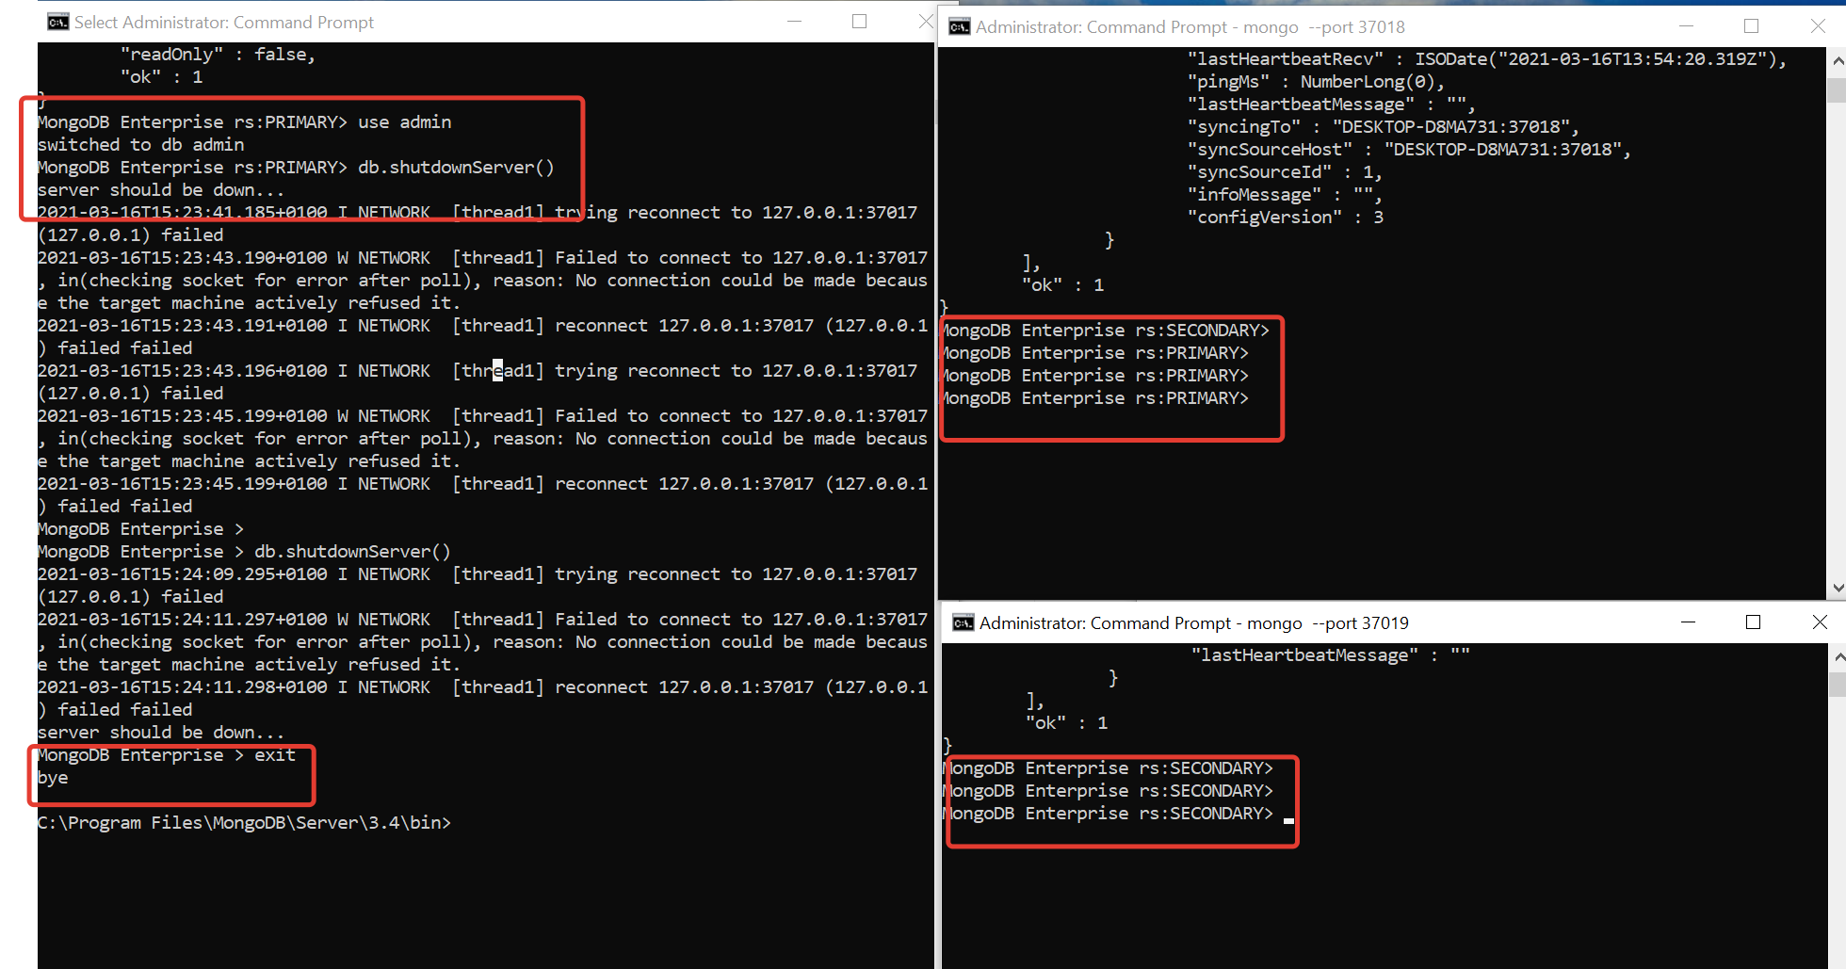

**Replica election**

|  |  |  |  |  |  |
| --- | --- | --- | --- | --- | --- |
| Server Port | After replica Config | 1st server shutdown | 1st & 2nd server shutdown | 2 server is running | All server running |
| 37017 | Primary | Shutdown | Shutdown | Shutdown | Secondary |
| 37018 | Secondary | Primary | Shutdown | Primary | Primary |
| 37019 | Secondary | Secondary | Secondary | Secondary | Secondary |

**After shutdown all server active**

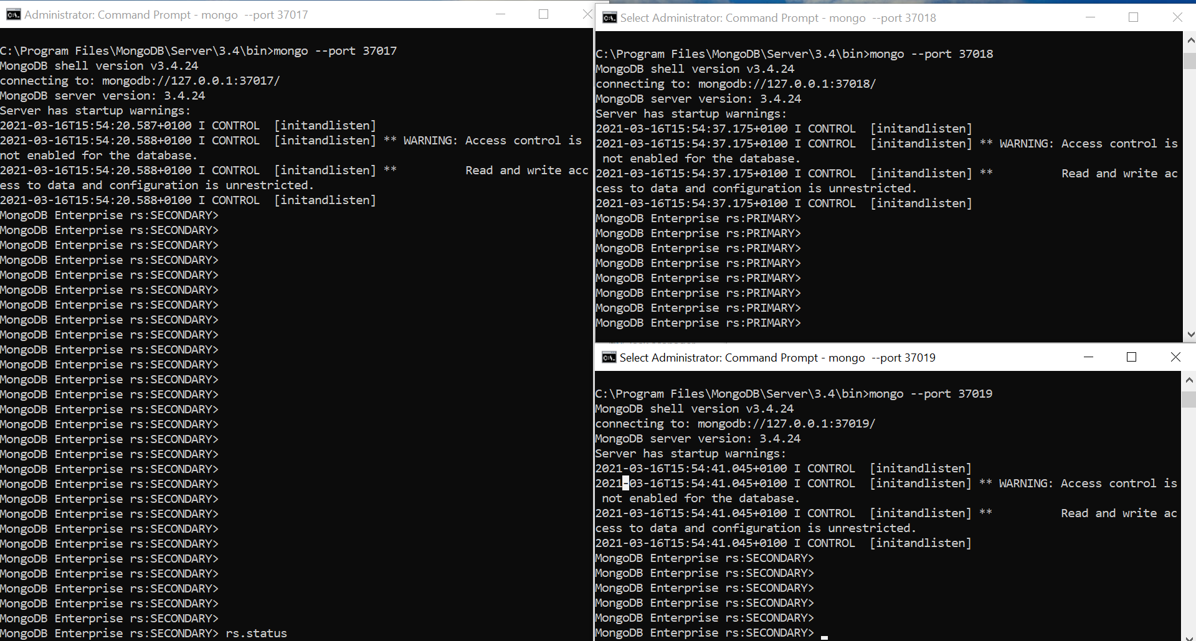

CURD Operation: Creating Database ”Products” 